Manav rachna university

Python Lab



NEERAJ DWIVEDI

B-TCEH CSE 4C

2K18CSUN01030

1. Write a Python program to create a tuple.

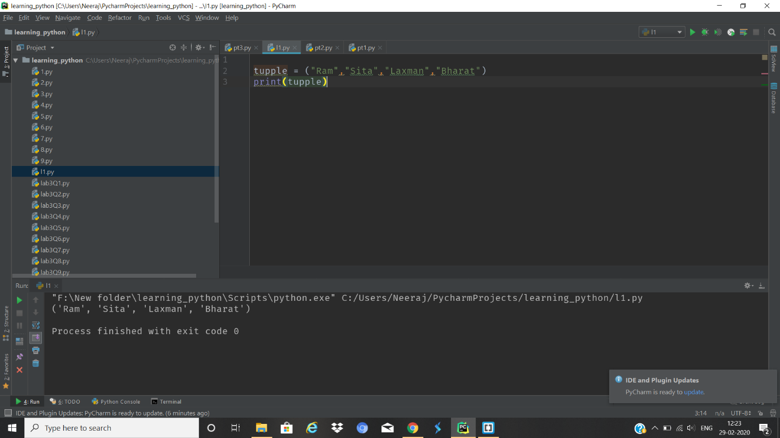

1. Write a Python program to create a tuple with different data types.

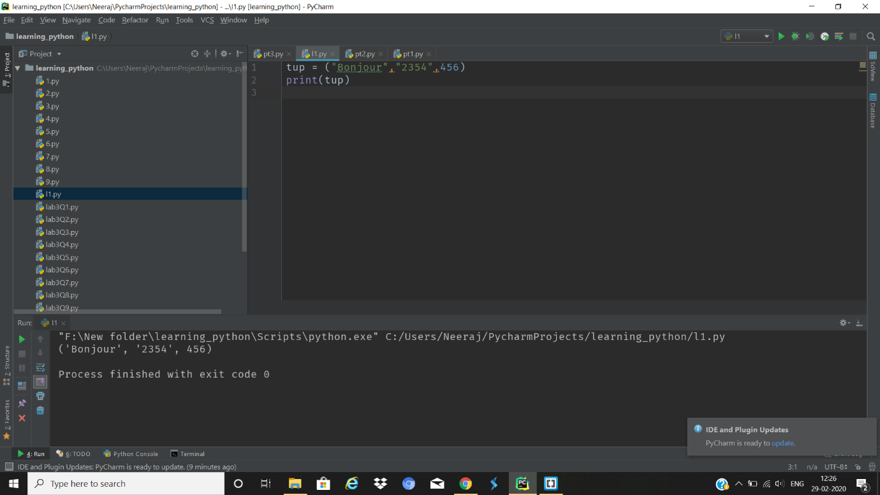

3. Write a Python program to create a tuple with numbers and print one

item.

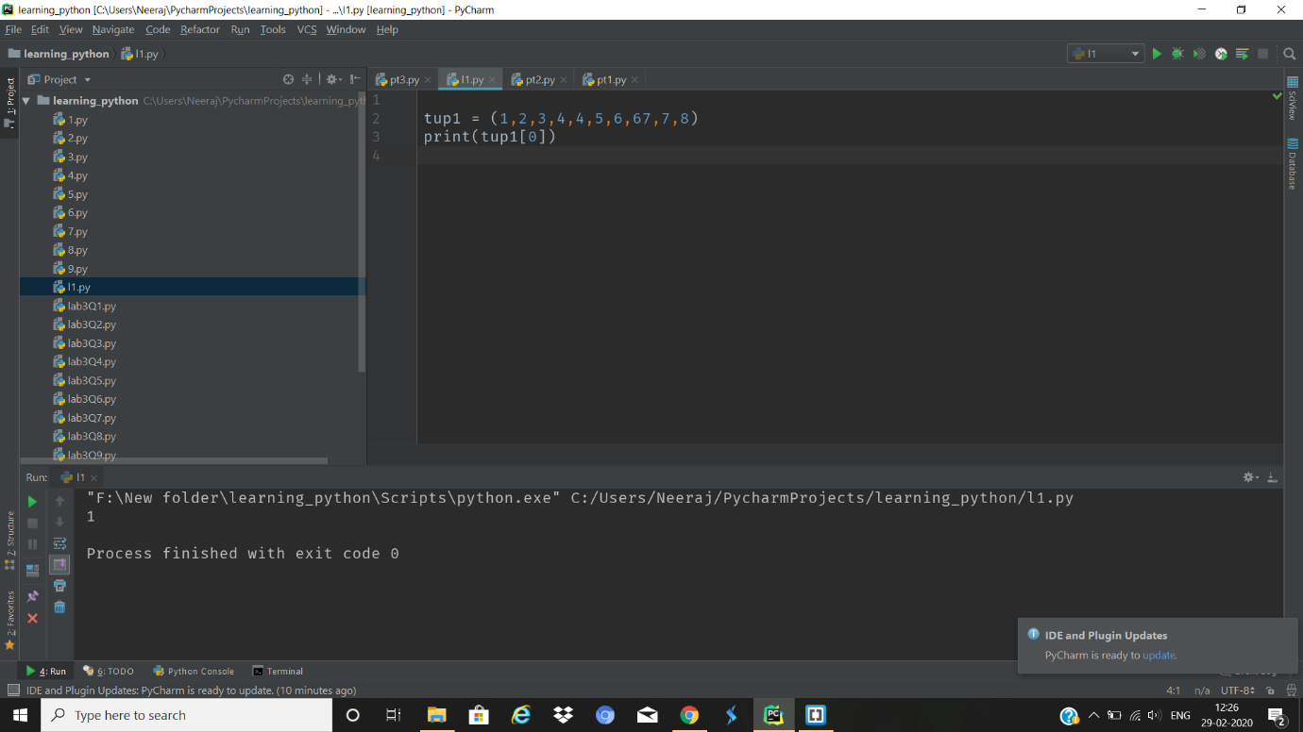

4. Write a Python program to unpack a tuple in several variables.

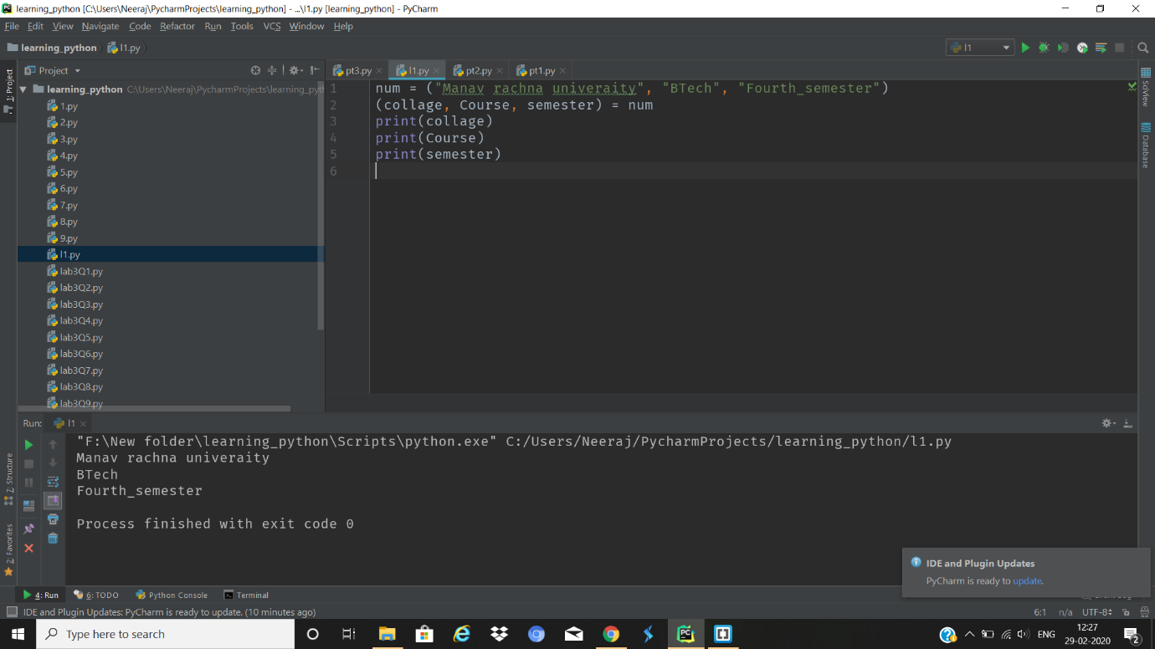

5. Write a Python program to add an item in a tuple.

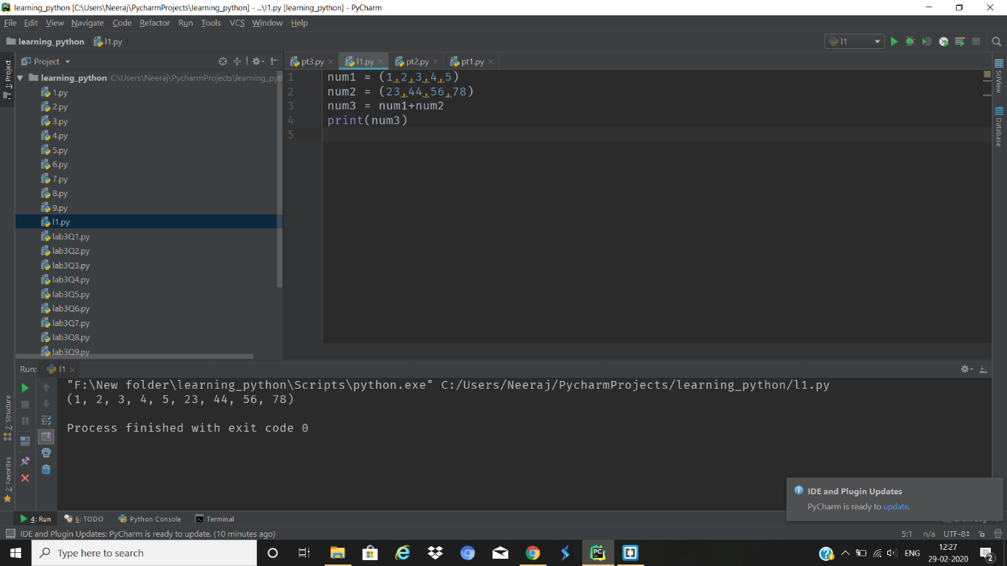

6. Write a Python program to convert a tuple to a string.

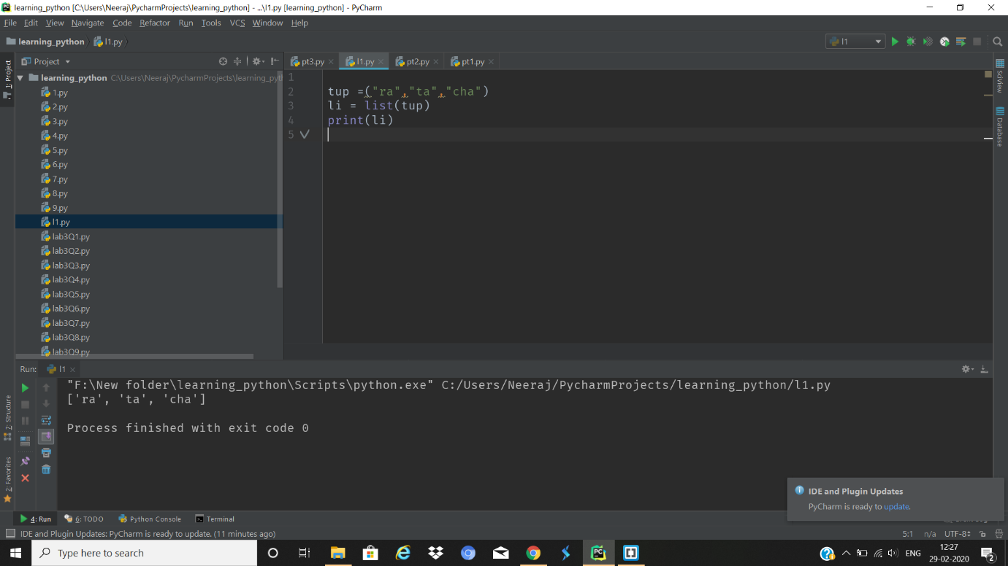

7. Write a Python program to get the 4th element and 4th element from

last of a tuple

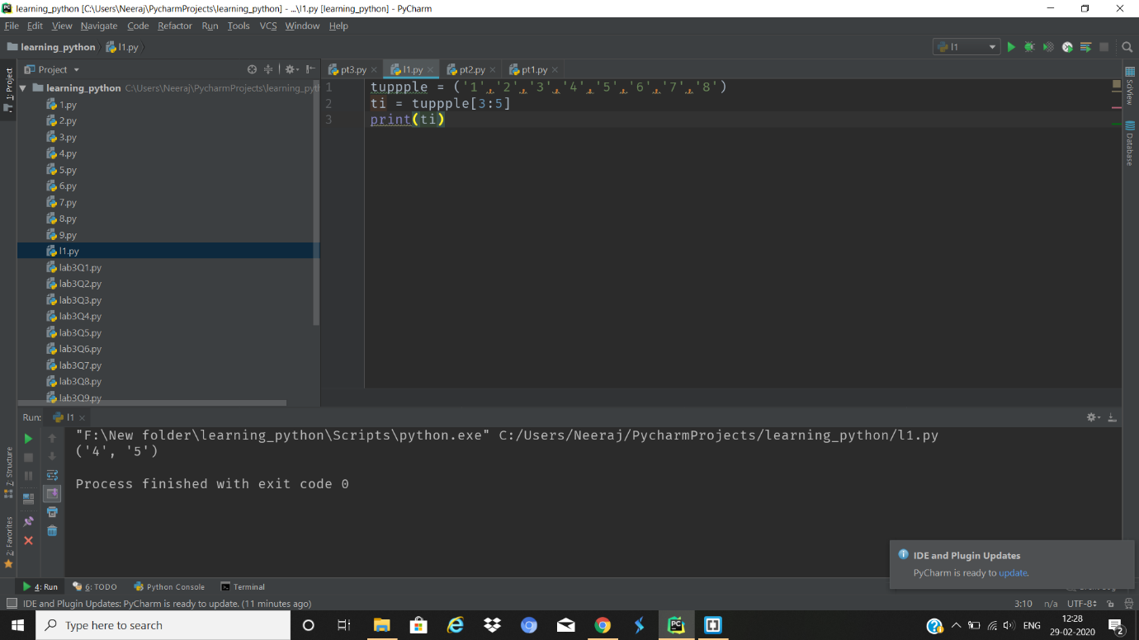

8. Write a Python program to create the colon of a tuple.

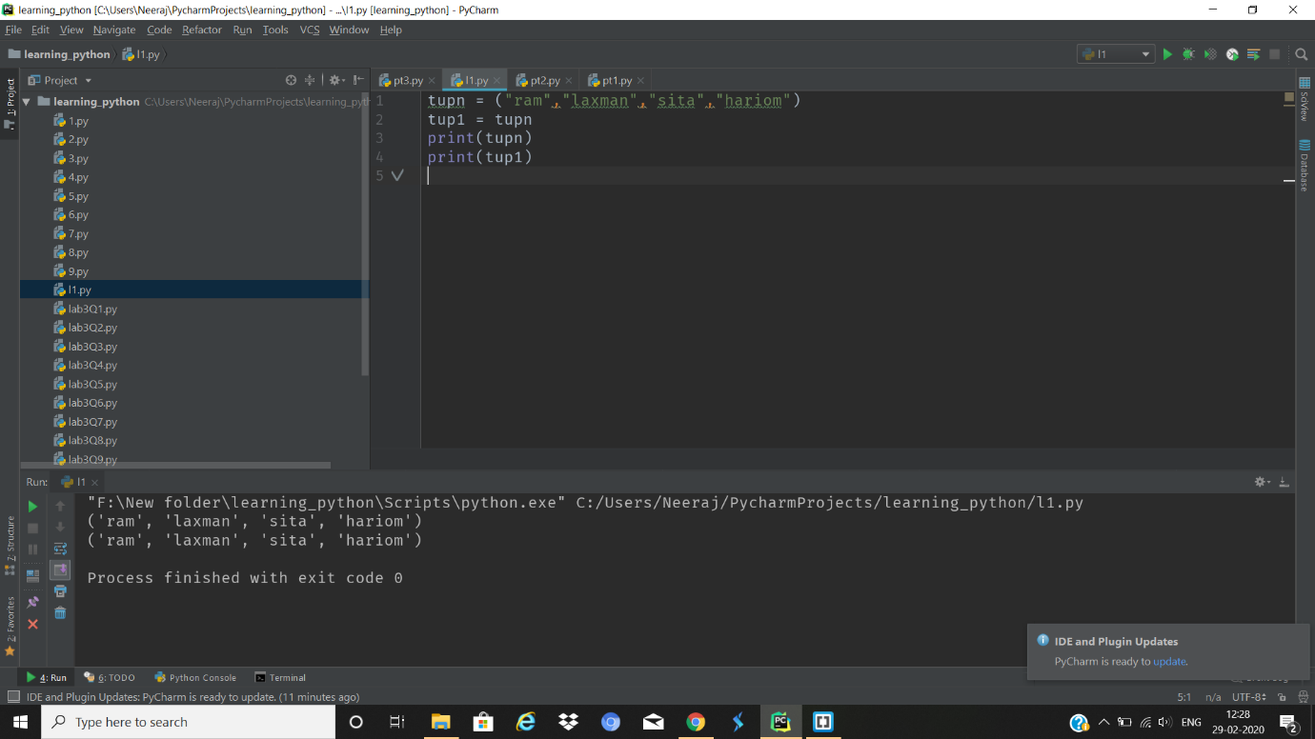

9. Write a Python program to find the repeated items of a tuple.

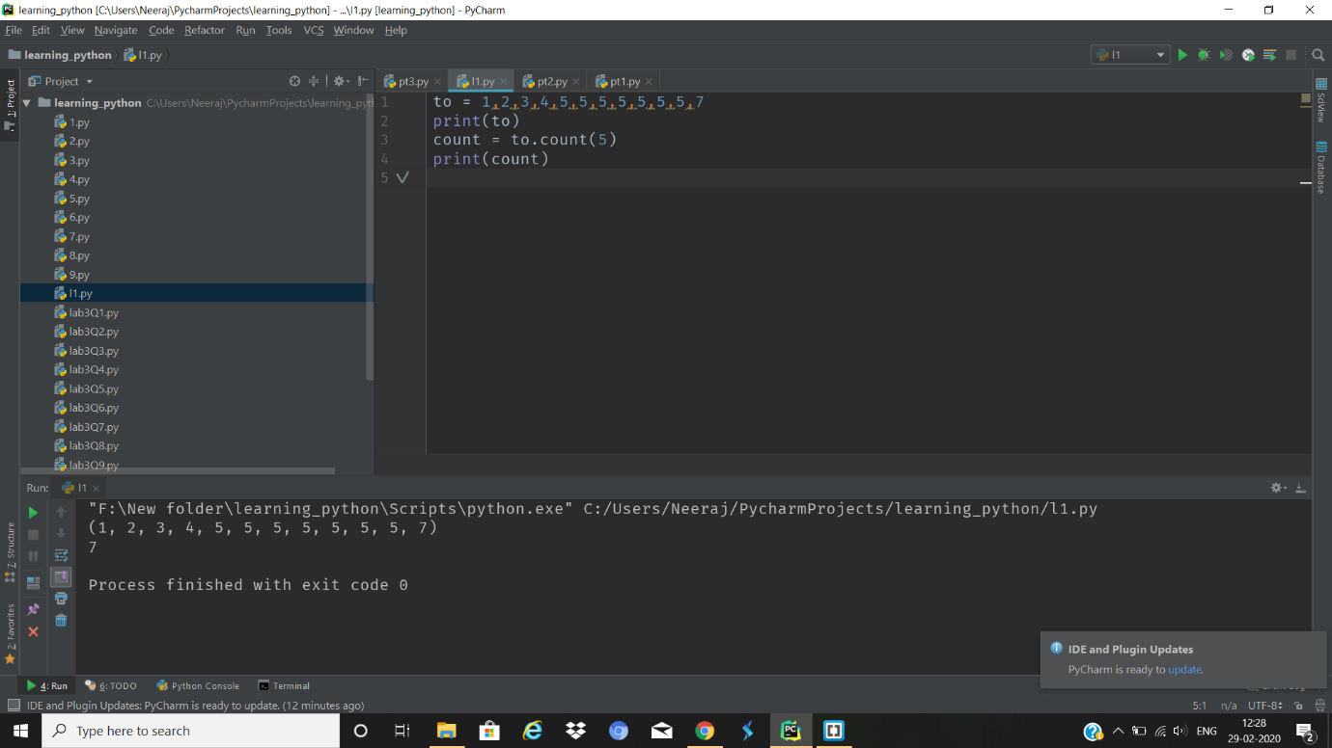

10. Write a Python program to check whether an element exists within a

tuple.

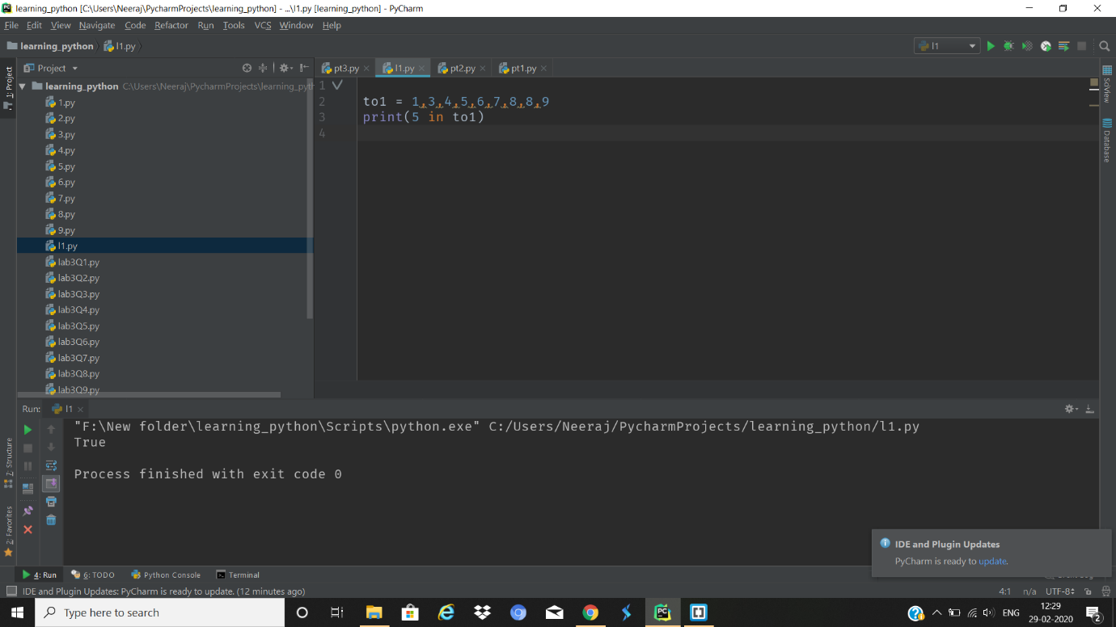

11. Write a Python program to convert a list to a tuple.

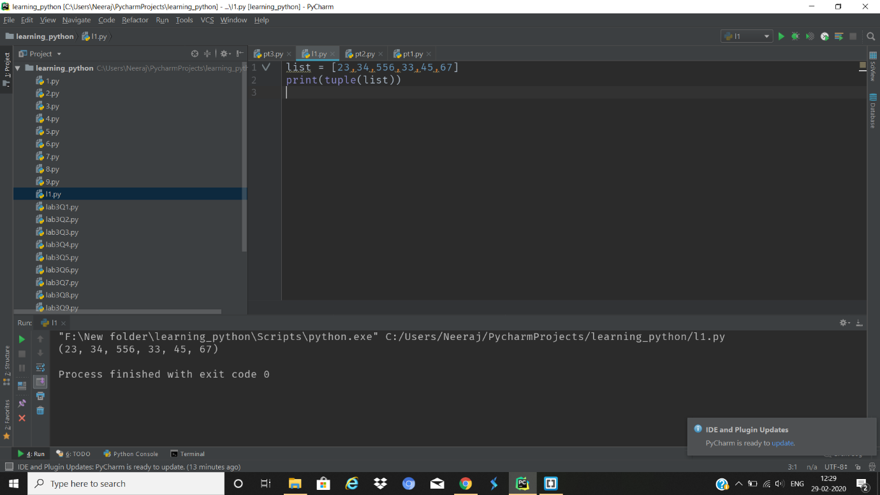

12. Write a Python program to remove an item from a tuple.

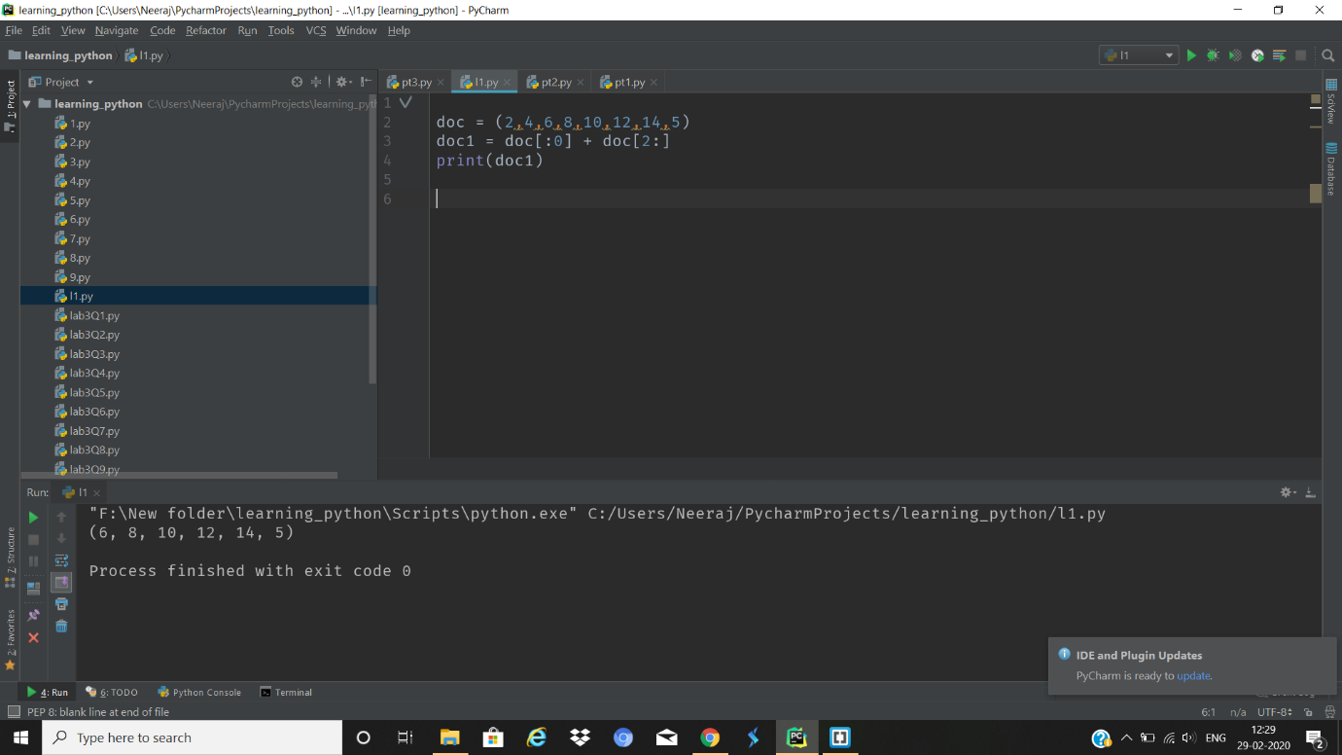

13. Write a Python program to slice a tuple

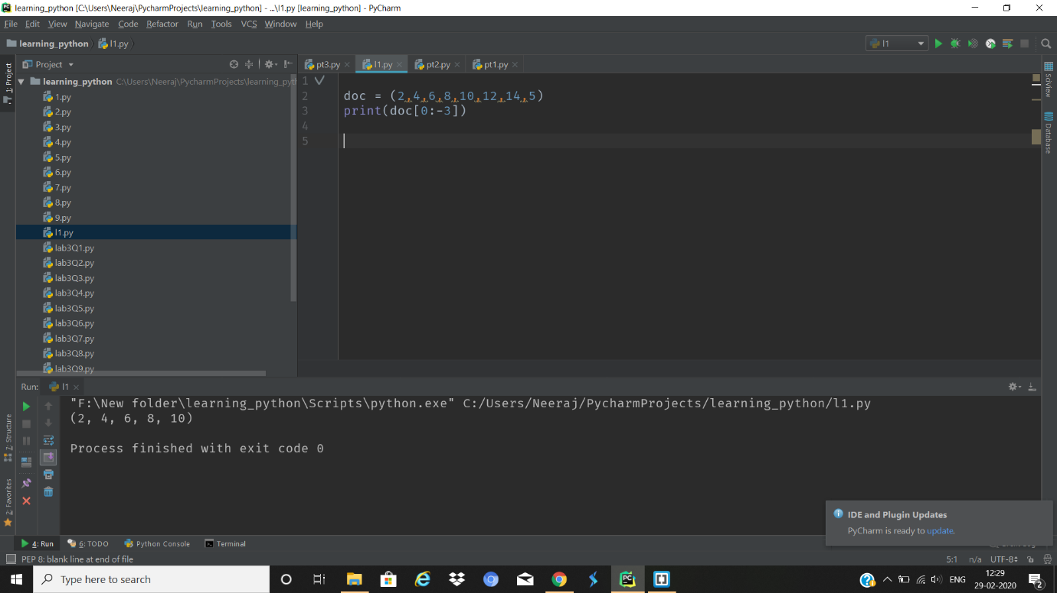

14. Write a Python program to find the index of an item of a tuple.

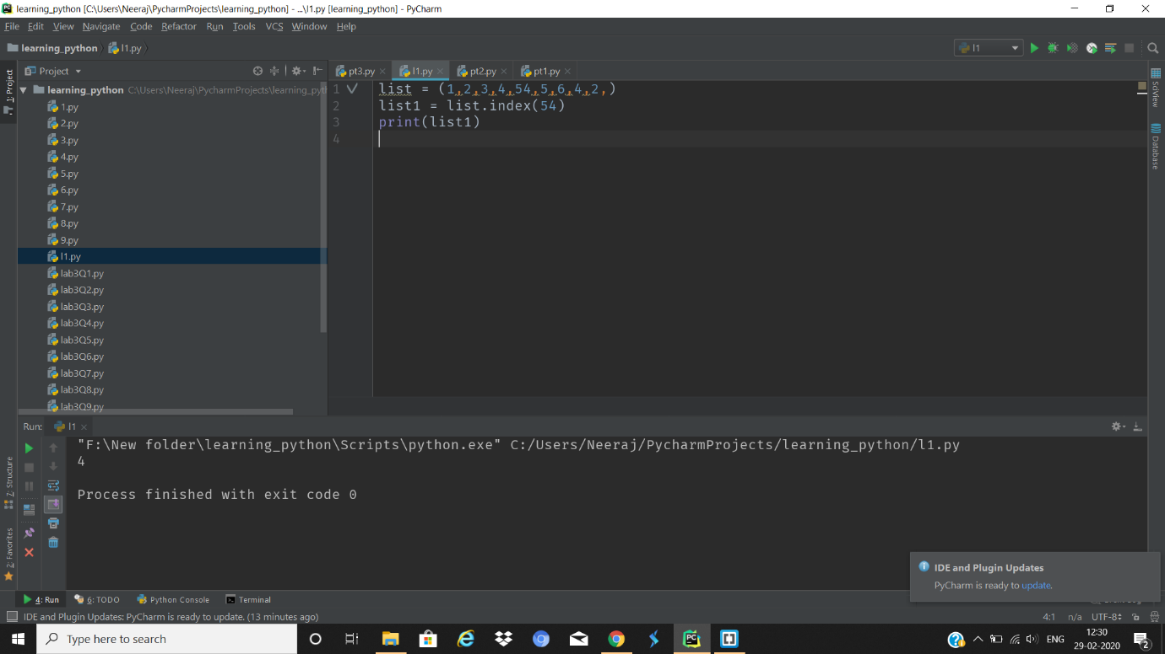

15. Write a Python program to find the length of a tuple.

